# Άσκηση 3.3

Πίνακας . Υποδίκτυο Κλάσης C - παράμετροι

|  |  |
| --- | --- |
| **Διεύθυνση υποδικτύου (subnetID)** | 192.168.0.0 |
| **Μάσκα υποδικτύου (subnet mask)** | 255.255.255.240 |
| **Πλήθος bit μάσκας (mask bits)** | 28 |
| **Διεύθυνση broadcast (broadcast address)** | 192.168.0.15 |
| **Πλήθος υποδικτύων (# subnets)** | 16 |
| **Πλήθος κόμβων ανά υποδίκτυο (hosts / subnet)** | 14 |
| **Εύρος διευθύνσεων κόμβων (host address range)** | 192.168.0.1 - 192.168.0.14 |

# Άσκηση 3.4

Πίνακας . Κυριότερες πόρτες - υπηρεσίες

|  |  |  |
| --- | --- | --- |
| **Πόρτα** | **Υπηρεσία** | **Εφαρμογή** |
| 20 | File Transfer Protocol (FTP) Data Transfer | FilleZilla |
| 21 | File Transfer Protocol (FTP) Command Control |  |
| 22 | Secure Shell (SSH) Secure Login | PuTTY |
| 23 | Telnet remote login service, unencrypted text messages | ZOC |
| 25 | Simple Mail Transfer Protocol (SMTP) E-mail routing | Outlook |
| 53 | Domain Name System (DNS) service | Simple DNS Plus |
| 80 | Hypertext Transfer Protocol (HTTP) used in the World Wide Web |  |
| 110 | Post Office Protocol (POP3) | Gmail |
| 119 | Network News Transfer Protocol (NNTP) |  |
| 123 | Network Time Protocol (NTP) | NetTime |
| 143 | Internet Message Access Protocol (IMAP) Management of digital mail | Yahoo |
| 161 | Simple Network Management Protocol (SNMP) | Solarwinds NPM |
| 194 | Internet Relay Chat (IRC) | HexChat |
| 443 | HTTP Secure (HTTPS) HTTP over TLS/SSL | SandBoxie |

# Άσκηση 3.5

## Δημοφιλέστερες δωρεάν υπηρεσίες DNS :

1. Google: Google can achieve fast speeds with their public DNS servers because they're hosted in data centers all around the world, meaning that when you attempt to access a web page using the IP addresses above, you're directed to a server that's nearest to you.
2. Quad9: Quad9 has free public DNS servers that protect your computer and other devices from cyber threats by immediately and automatically blocking access to unsafe websites, without storing your personal data.
3. OpenDNS Home: OpenDNS claims 100% reliability and up-time and is used by 90 million users around the world. The offer two sets of free public DNS servers, one of which is just for parental controls with dozens of filtering options.
4. CLOUDFLARE: Cloudflare built 1.1.1.1 to be the "fastest DNS service in the world" and will never log your IP address, never sell your data, and never use your data to target ads.
5. CLEANBROWSING: CleanBrowsing has three free public DNS server options: a security filter, adult filter, and family filter. The CleanBrowsing adult filter (185.228.168.10) prevents access to adult domains, and the family filter (185.228.168.168) blocks proxies, VPNs, and mixed adult content.
6. VERISIGN: Verisign's public DNS services are centered around stability and security with 100% up-time, as well as privacy, citing that they "will not sell your public DNS data to third parties nor redirect your queries to serve you any ads."
7. ALTERNATE DNS: Alternate DNS is a free public DNS service that blocks ads before they reach your network.
8. ADGUARD DNS: AdGuard DNS has two sets of DNS servers, both of which block ads in games, videos, apps, and web pages. The basic set of DNS servers are called the "Default" servers, and block not only ads but also malware and phishing websites. There are also "Family protection" servers (176.103.130.132 & 176.103.130.134) that block adult content plus everything included in the "Default" servers

# Άσκηση 3.6

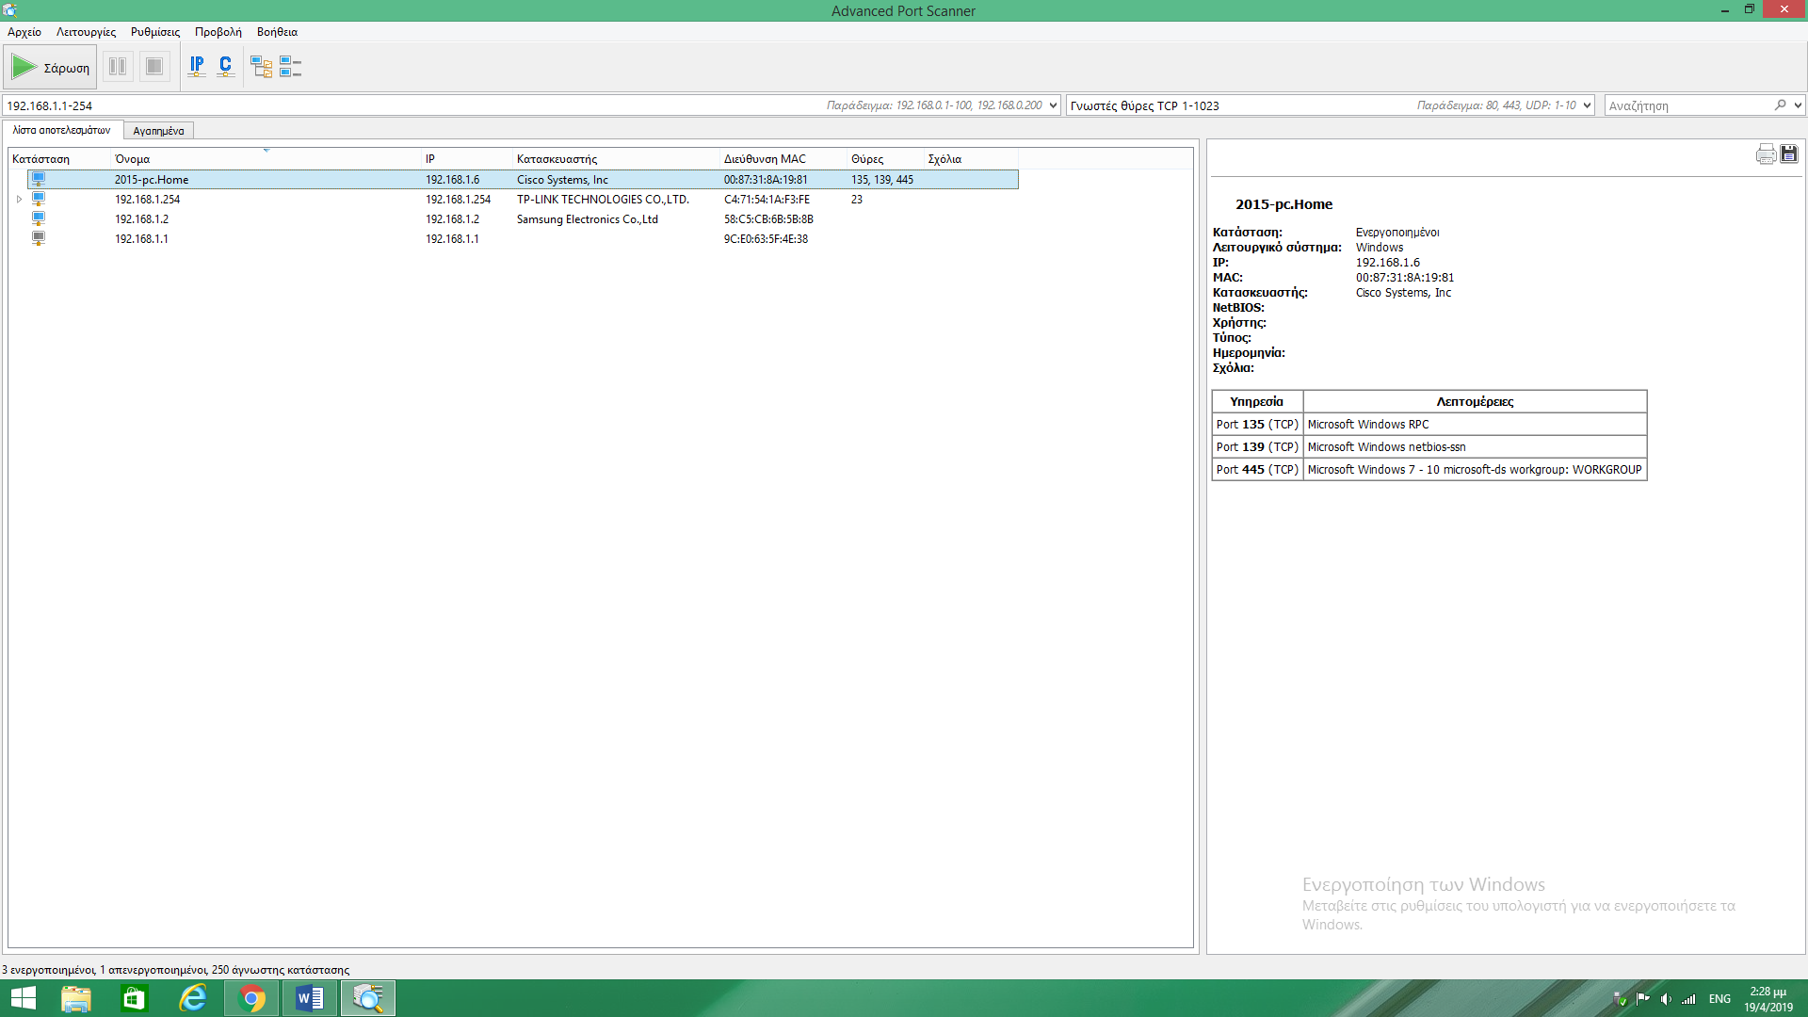

Εικόνα . Εκτέλεση port scanner στο ασύρματο δίκτυο της οικίας μου

# Άσκηση 3.7

Πραγματοποιώντας τον έλεγχο ταχύτητας, διαπιστώνω ότι η ταχύτητα της λήψης (Download) είναι αρκέτα μεγαλύτερη απο την ταχύτητα ανεβάσματος (Upload). Αυτό σημαίνει πως εάν θελήσω να ανεβάσω ένα οποιοδήποτε αρχείο θα μου πάρει πάρα πολύ χρόνο, πόσο μάλλον σε σχέση με το να το κατεβάσω.

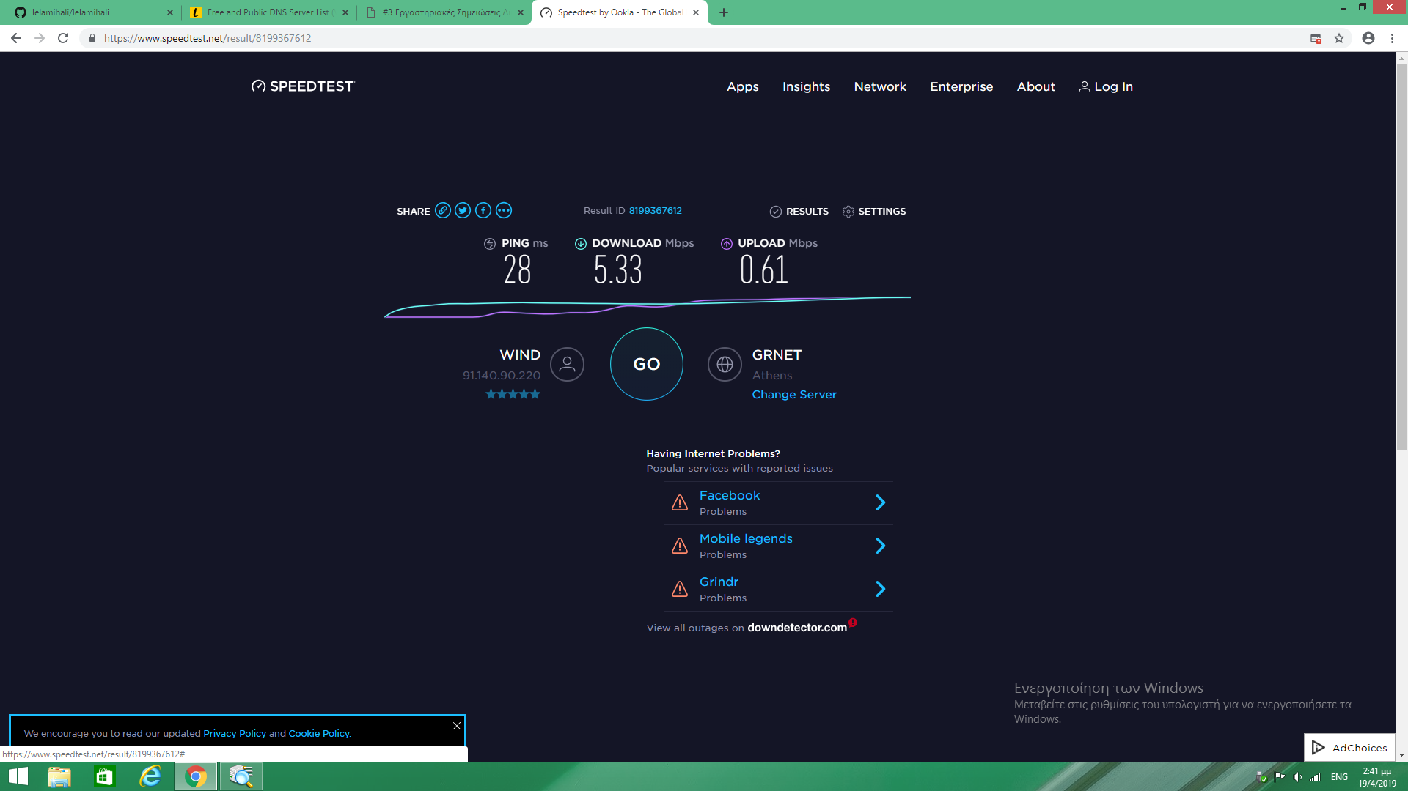

Εικόνα . Παράδειγμα εκτέλεσης ελέγχου ταχύτητα